Self Care During Corona Virus
Ann Hamden- Mental Health Trainer, Credentialed Mental Health Nurse, RN, MN
www.talkingmentalhealth.com.au

Be aware of your Mental Health  A mental illness is a condition that causes major changes  to thoughts, feelings and behaviour, affecting our everyday functioning  and is persistent over time. This is how it differs to too having a bad  day or a few bad days. During this very testy period that we are all unfamiliar  with, it is even more important to take care of your mental health. So many of  us are anxious about the future and what this period of uncertainty may bring  to our lives.  We all know prevention is better than cure, so by looking after  yourselves and following some simple strategies, can really help  prevent a mental health problem arising.  People with a history of anxiety and depression may be more at risk  than someone who doesn’t have a history.  So keep an eye on friends family and friends who you know may be  more susceptible.  Look out for each other and don’t be afraid to ask how someone is if  you notice changes from the norm.  Symptoms like, persistent low mood, poor sleep and appetite, lack of  motivation and even thoughts of suicide are amongst some of the most  common signs and symptoms.  Talking to the person non-judgementally and helping  them find the right services and resources can make a significant  difference to the outcome. Don’t be afraid to ask for help if it is  happening with you.  Beyond Blue has excellent resources and a Helpline that is confidential  Ph: 1300 22 4636. Even if you just want some advice on how to help a  family member or friend. | 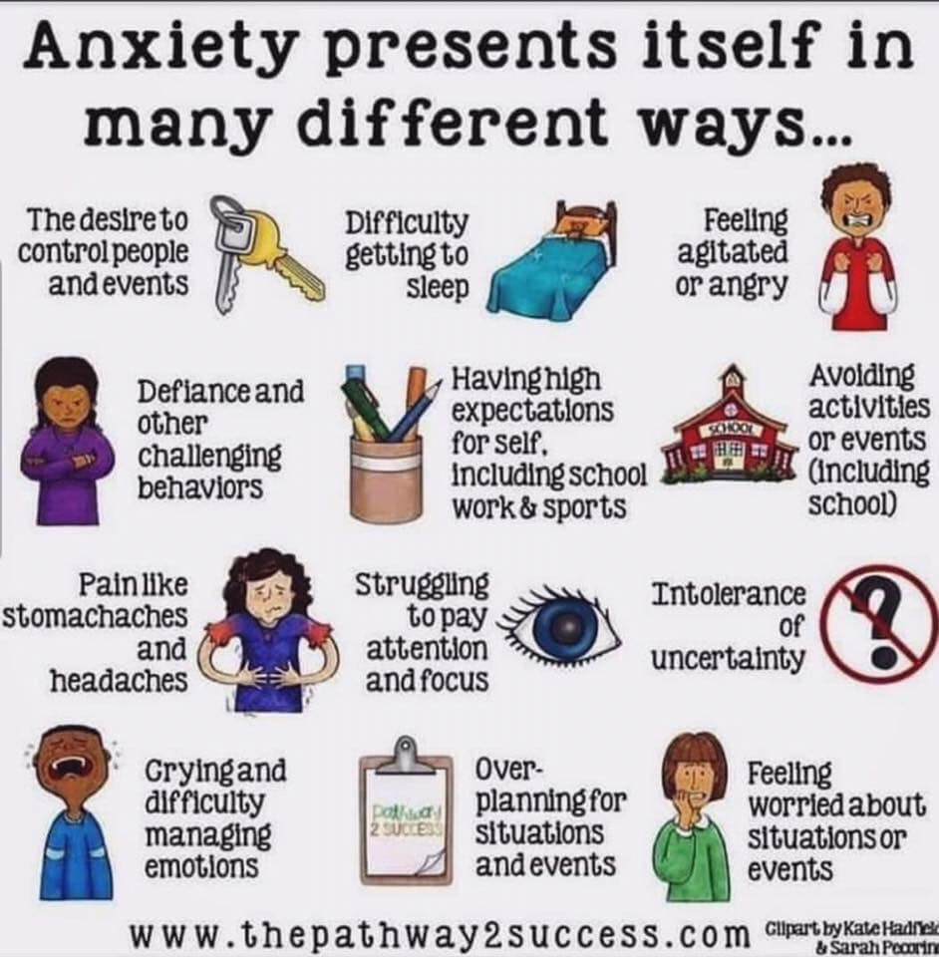

Try to keep a routine

Studies in resiliency during traumatic events encourage keeping a routine to your day. So eating meals at regular times, sleeping, waking and exercising at set times, and maintaining social (socially distant) contact are really important.

Unstructured time can create boredom, spikes in anxiety or depression, which can lead to unhealthy patterns of coping. Another reason is that keeping a routine reduces “decision fatigue,” the overwhelm and exhaustion that can come from too many options. It’s better to have a schedule that everyone can follow, and try to stick with it as much as you can. Don’t be hard on yourself if it doesn’t always work, and it’s sure not going to work some days. This will free up some mind space during this time of uncertainty, which is already straining everyone’s cognitive capacities.

Get outside—in nature—if you can
There are are some very good reasons to go outside. Lots of recent research finds that spending time in nature is a boon to both mental and physical health. For instance, multiple studies have found that time in green and blue space is associated with reduced anxiety and depression, and the connection may well be a causal one.
So go for a walk, sit out in the sunshine and get out to the park and breathe in fresh air, while being sure sure to practice good social distancing. It’s a really good habit for body and mind.

Meditate, or just breathe  Meditation is well researched and shown to reduce symptoms of depression and anxiety, and even increase the volume of certain areas of the brain. There are plenty of phone app’s and online courses available for free. But if meditation isn’t for you, just breathing slowly might be. Controlled breathing has been used for millennia to calm the mind.  Meditation is well researched and shown to reduce symptoms of depression and anxiety, and even increase the volume of certain areas of the brain. There are plenty of phone app’s and online courses available for free. But if meditation isn’t for you, just breathing slowly might be. Controlled breathing has been used for millennia to calm the mind. | 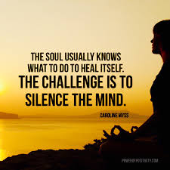
Maintain community and social connection
As mentioned, we’re fundamentally social creatures, and during crises it’s natural to want to gather. Social connectivity is the perhaps the greatest determinant of wellbeing there is. Texting and social media are ok, but picking up the phone and talking or videoconferencing, or having a safe-distance conversation on the street, is probably much better.

Practice Gratitude  This is not the easiest thing to do in these times, particularly if you’ve been largely impacted by the pandemic such as job or business loss. Writing down five things one was grateful for just once a week is significantly linked to increased well-being. So even though it might be a challenge right now, write down some of the things you’re grateful for; or if you have little kids and it’s easier, try talking about it and listing aloud things that make you happy and that you’re thankful for. | 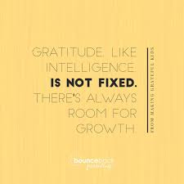
Let yourself off the hook
The might be the most important thing to keep in mind—don’t beat yourself up when things are not going perfectly in your household. On top of everything else, being upset with yourself is totally counterproductive. If the kids watch too much Netflix or play too many hours of video games, it’s not the end of the world. Things are going to be hairy for a while, and if you can’t stick to your schedule or can’t fit in your at-home workout every day, it’s really not such a big deal in the long run. It’s much more valuable to everyone to cut yourself some slack, use the time to reflect on the important things, and try to keep a sense of “we’re all in this together” at the forefront.

Access good quality information
Accurate information from credible sources such as those listed below will help you maintain perspective and feel more in control.
- Australian Government coronavirus (COVID-19) health alert
- Health Direct - Coronavirus (COVID 19)
- Smartraveller.gov.au- travel info for Australians
- World Health Organization – coronavirus disease (COVID-19) outbreak
- www.Beyondblue.org.au
- www.Blackdoginstitute.org.au

References: beyondblue.org.au forbes.com lifeline.org.au

